**Phase 3: Data Modelling & Relationships**

**Standard & Custom Objects:**

**Standard Object Include: Account and Contact**

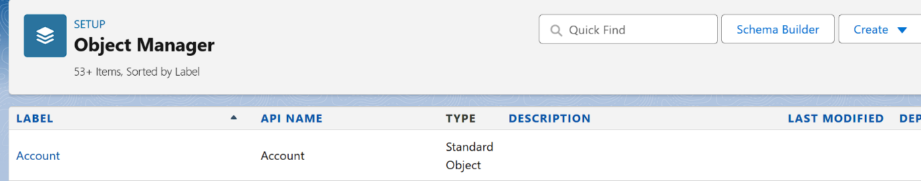



**Custom Object Include: Order, Product, Order item (Junction Object), Inventory**

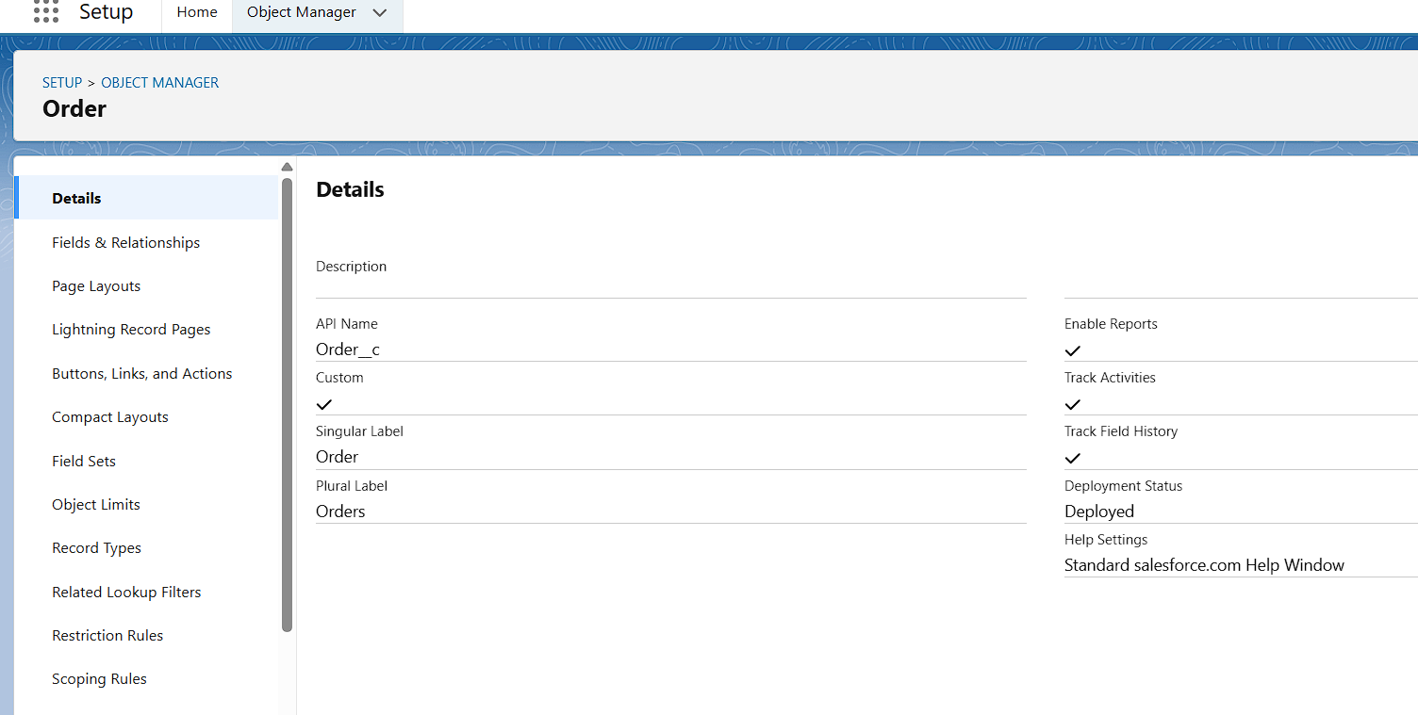

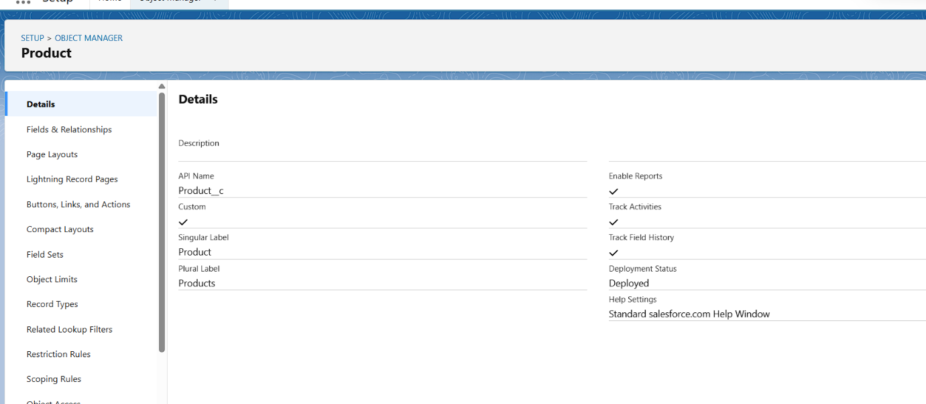

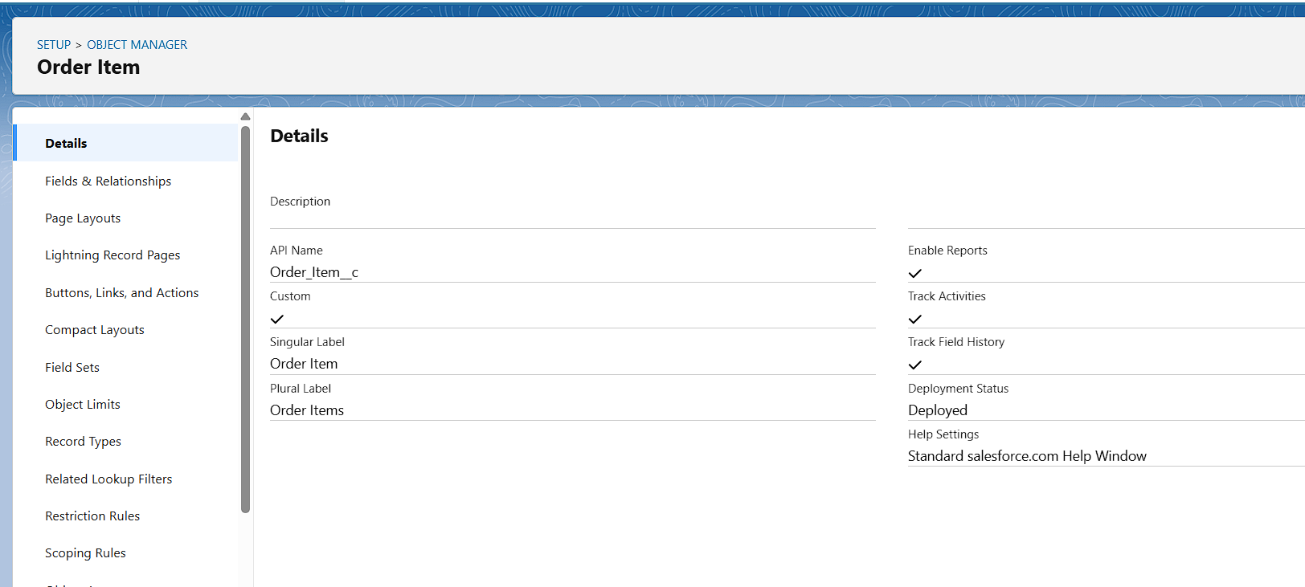

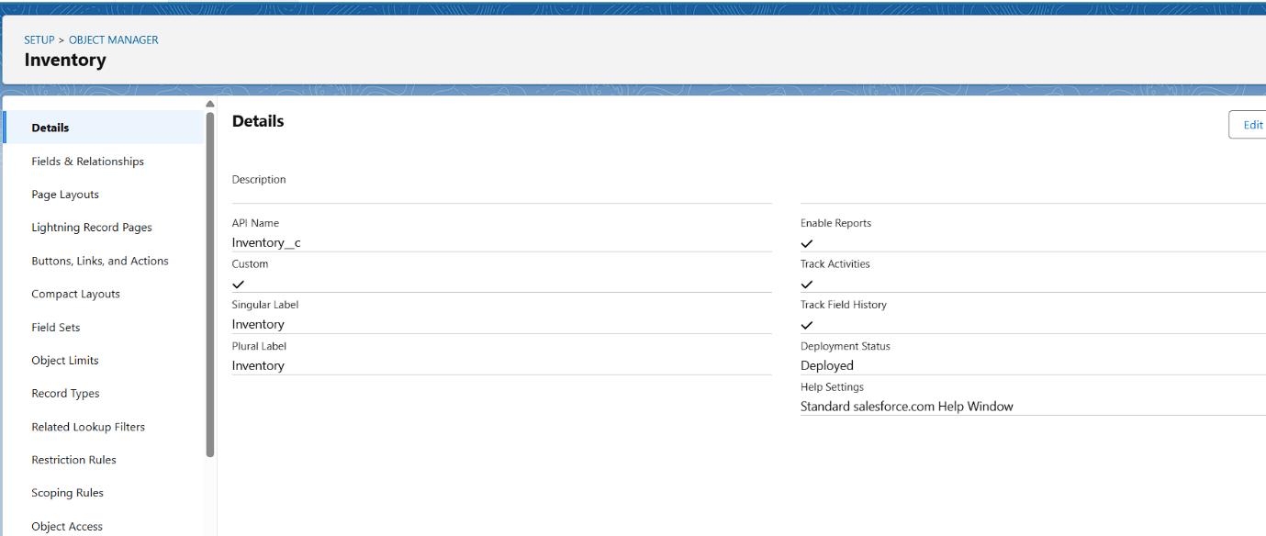

**Fields:**

**Account (Standard Object): Customer Type (Picklist), Payment Method (Picklist), GST/Tax Number**

**Customer Type (Picklist – Retail, Wholesale, Vip):**

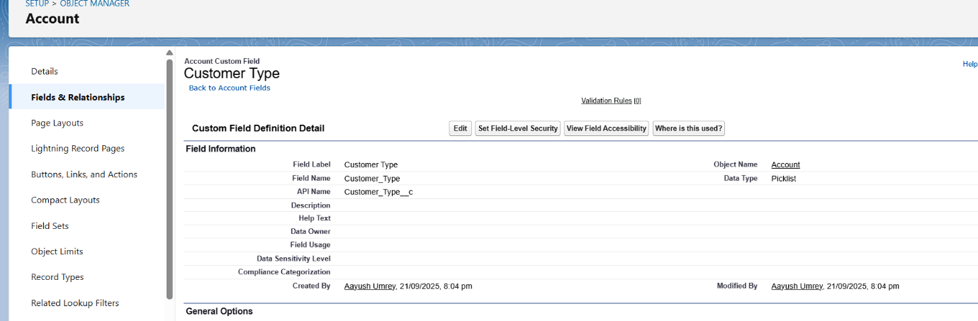

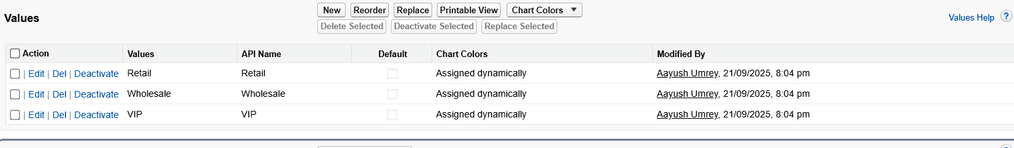

**Payment Method (Picklist – Cash, Card, UPI, Net Banking, Credit):**

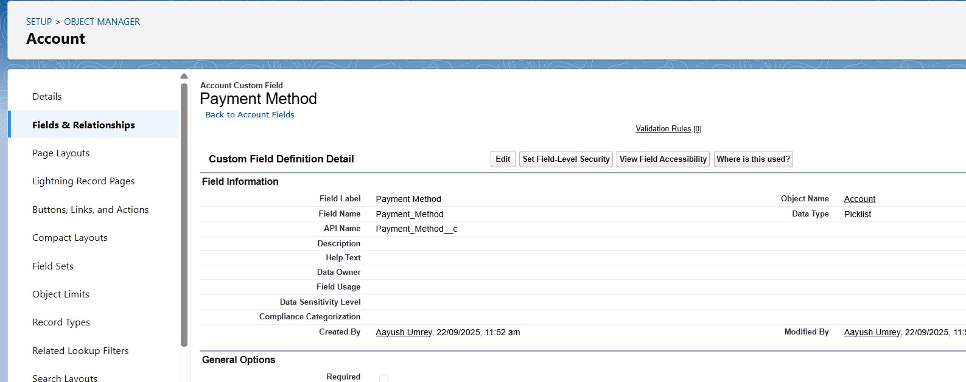

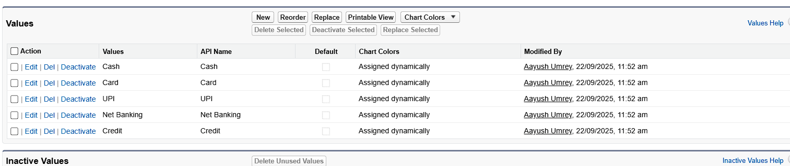

**GST/Tax Number (Text):**

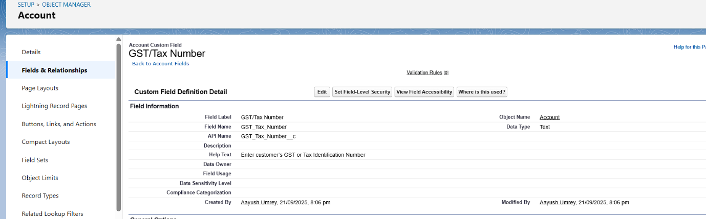

**Order (Custom Object):** Customer Name (Text), CustomerContact (Lookup -> Contact), Order Number (Auto Number), Order Date(Date/Time), Status (Picklist), Total Amount (Currency):

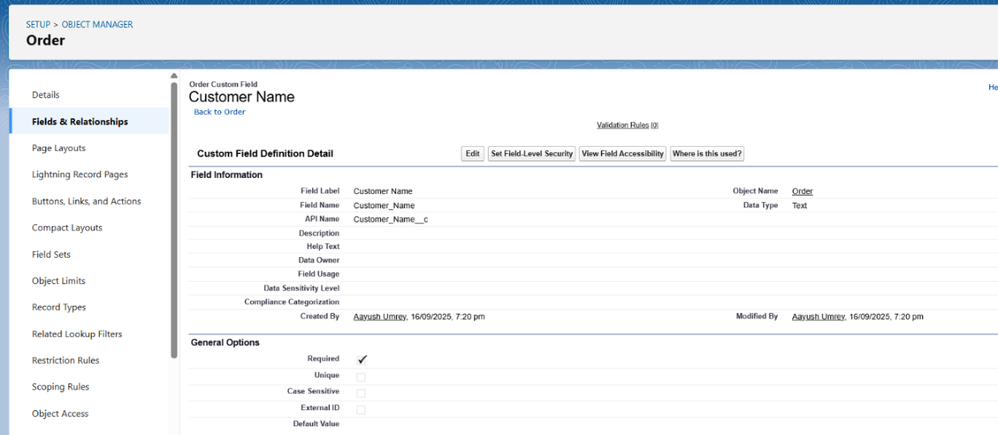

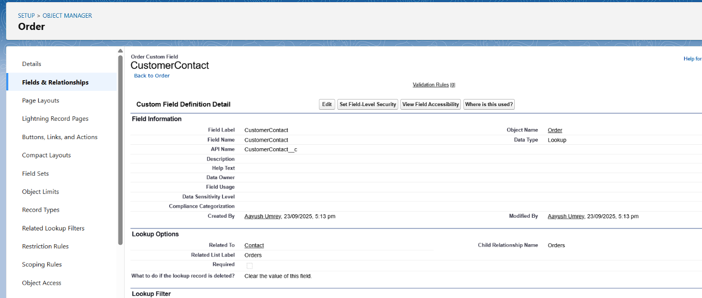

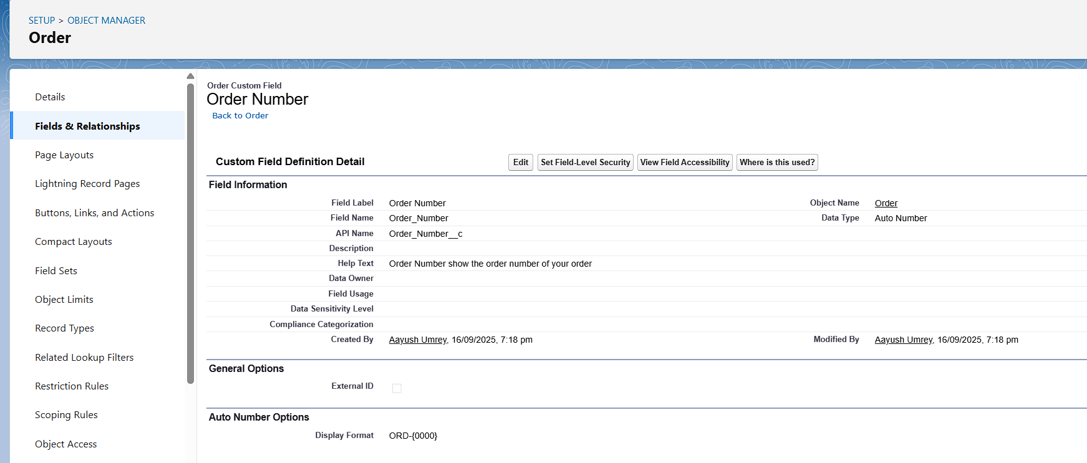

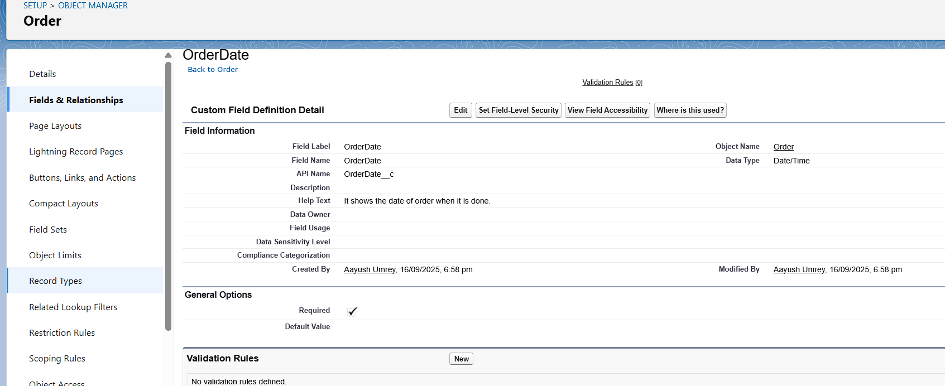

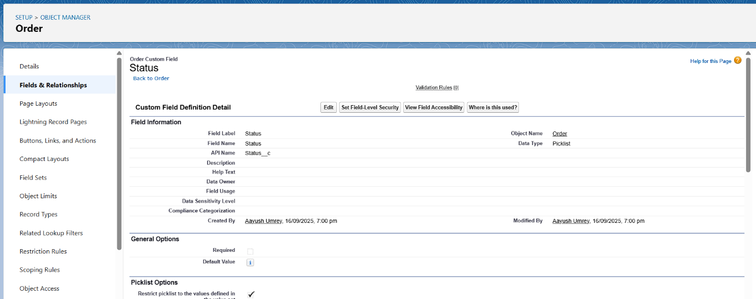

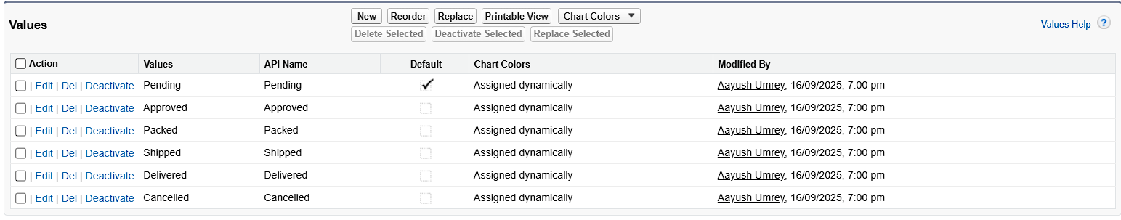

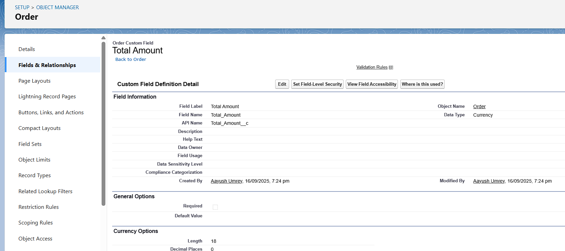

**Order Item (Custom Object):** Line Total (Formula - Quantity__c * Unit_Price__c), Order (Mater-Detail (Order)), Product (Lookup (Product)), Quantity(Number), Unit Prize(Currency)

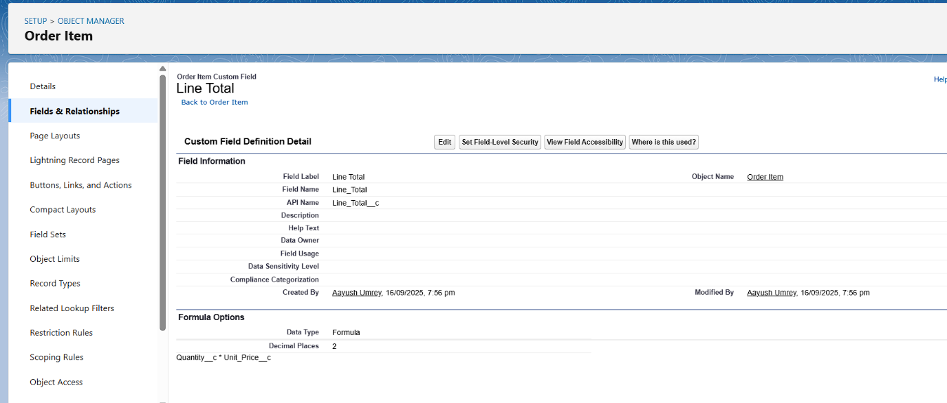

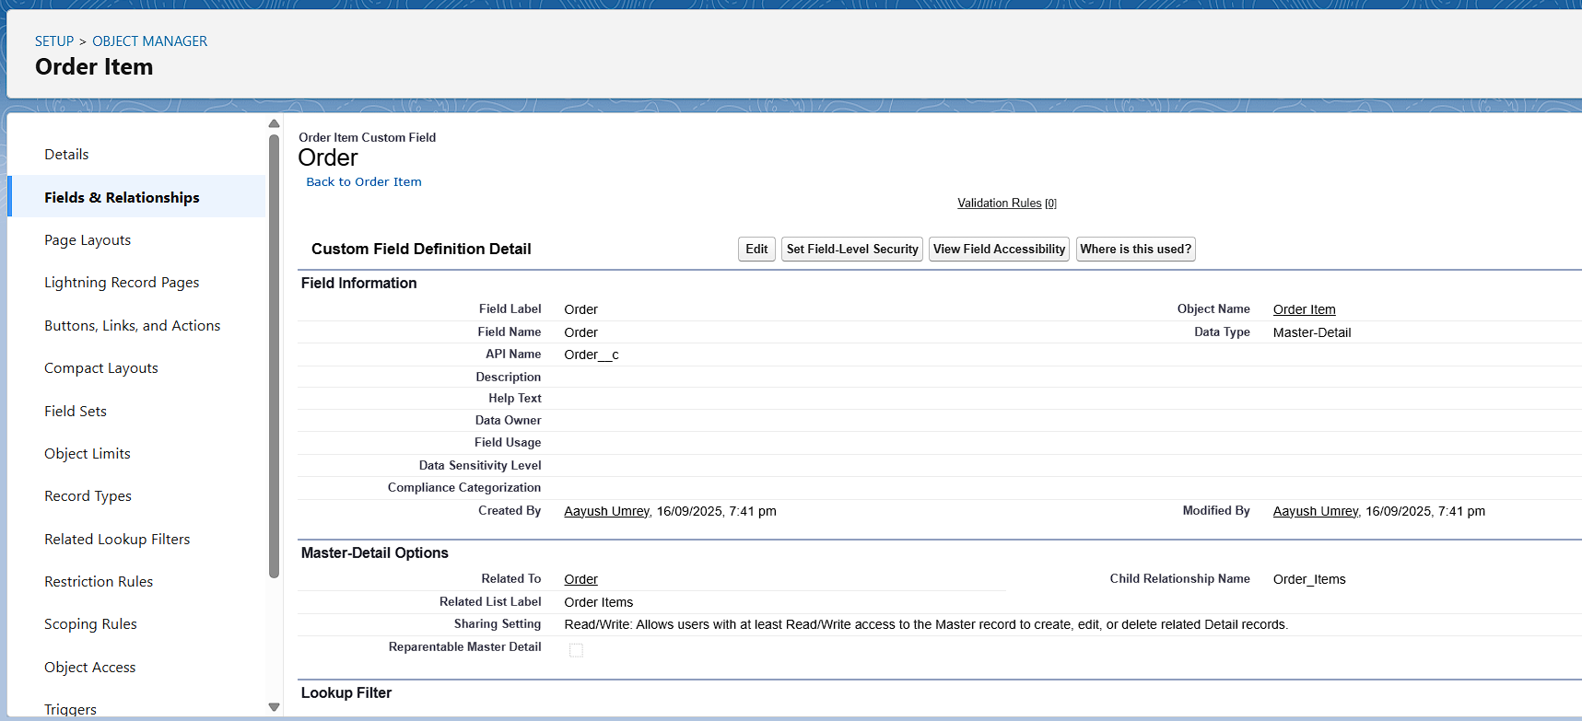

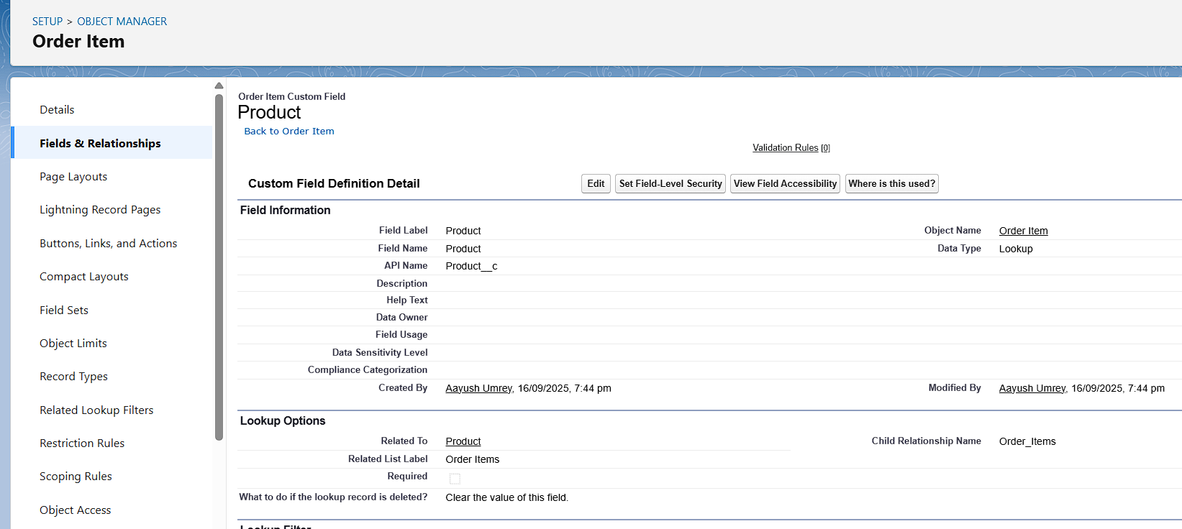

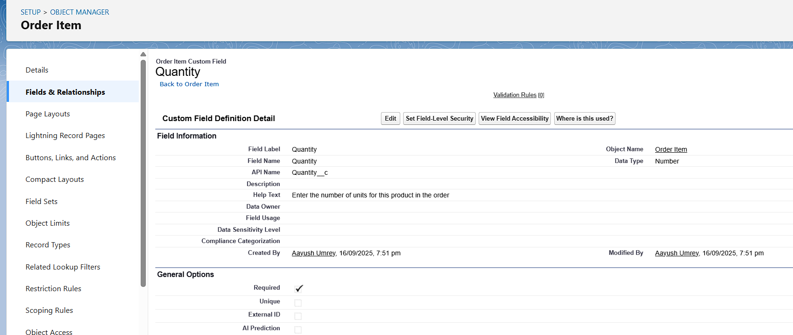

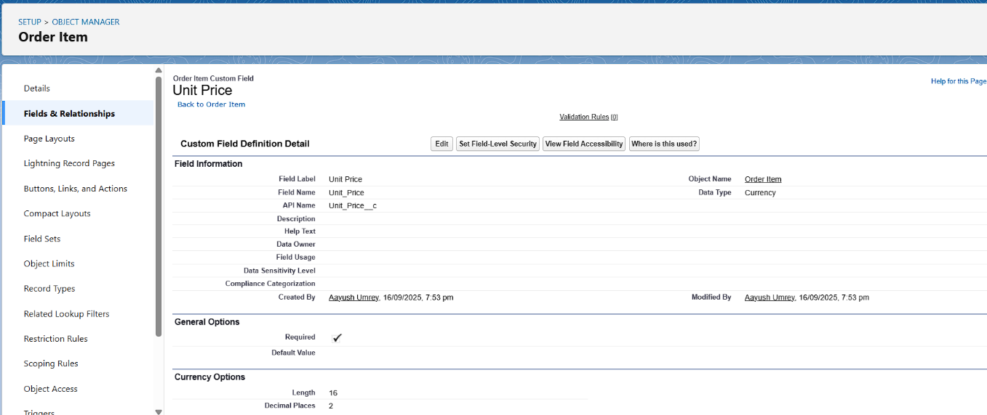

**Inventory (Custom Field):** Available Quantity (Formula - OnHandQty__c - ReservedQty__c), OnHandQty (Number), Product (Lookup (Product)), ReorderLevel (Number), ReservedQty (Number).

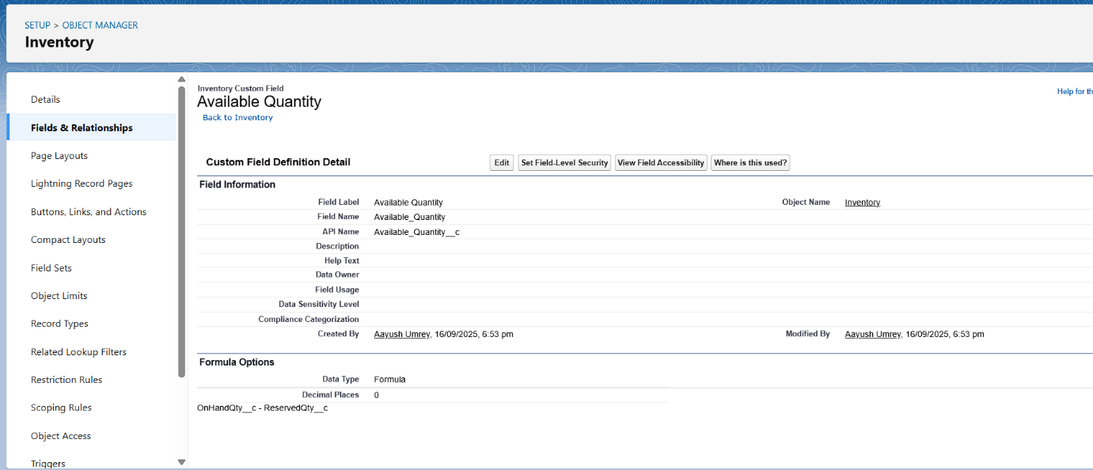

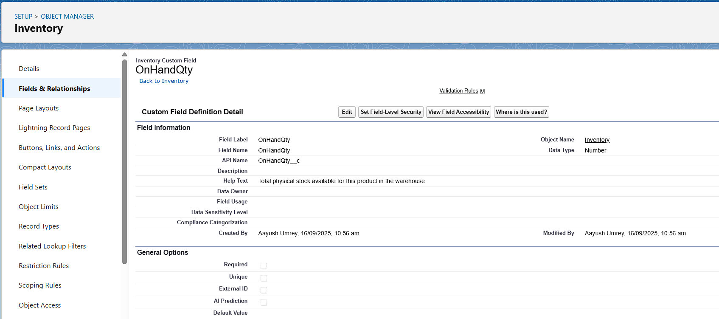

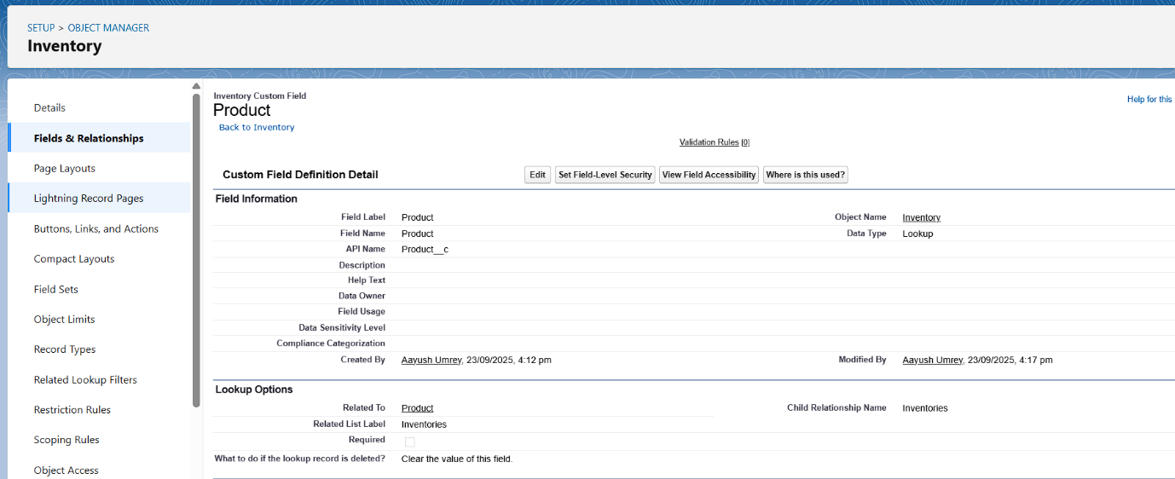

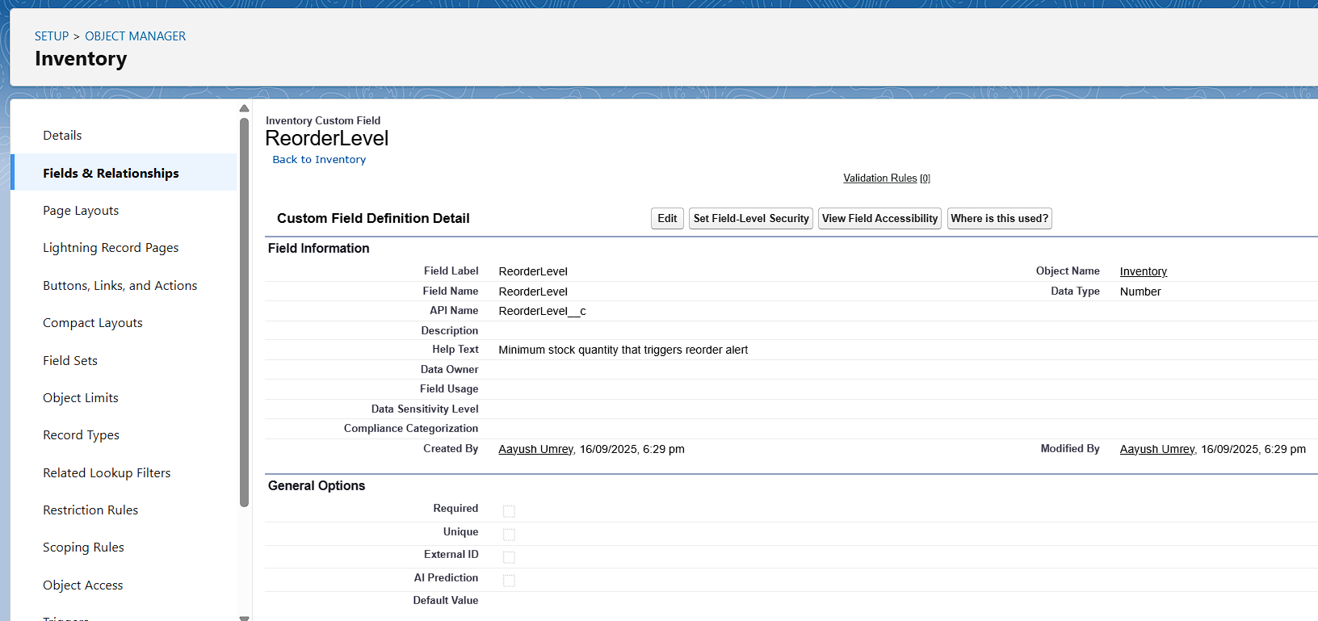

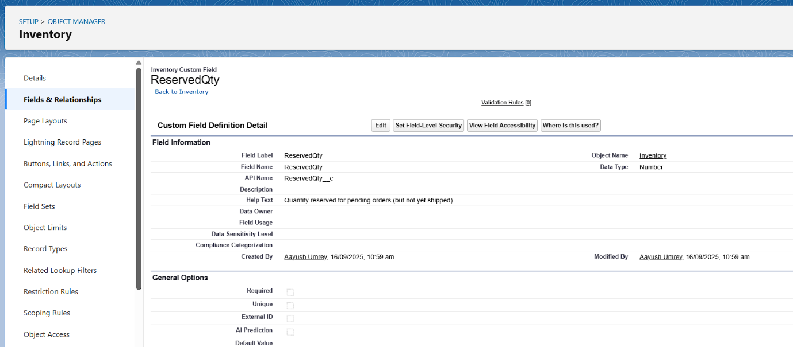

**Product(Custom Object):** Product Code (Auto Number), Price (Currency)

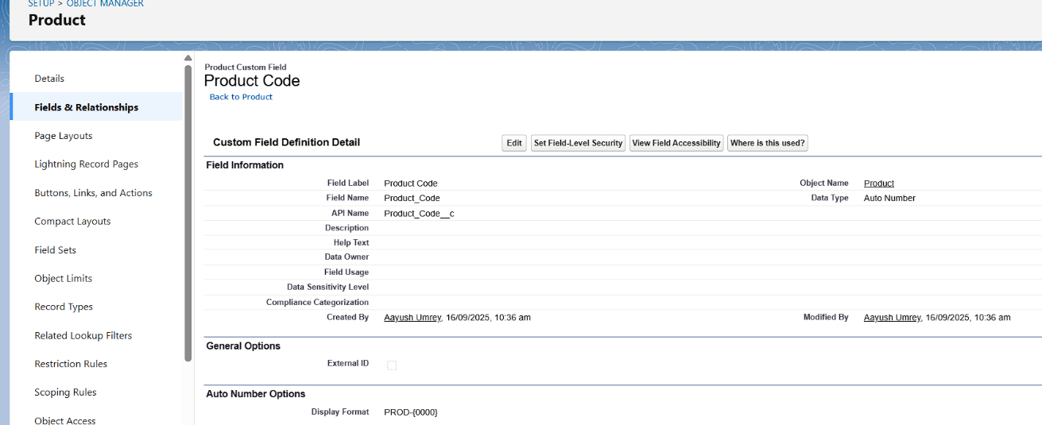

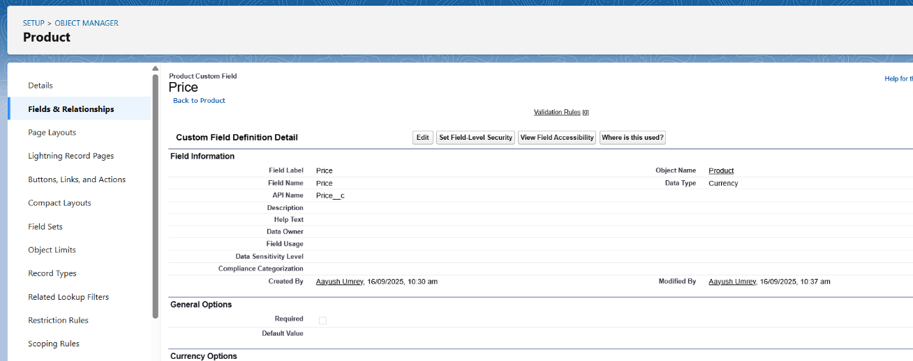

**Record Types:**

**Account:**

**B2C Account:** Accounts representing individual consumers

**B2B Account:** Accounts representing business/organization clients

|  |
| --- |
|  |

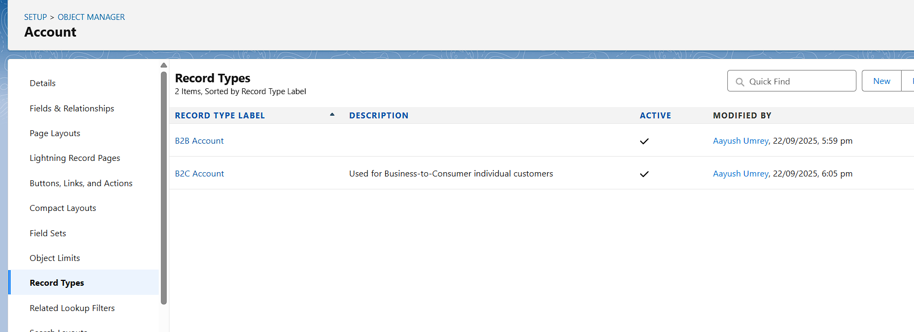

**Order:**

**Online Order:** Orders placed online by customers

**Bulk Order:** Orders placed in bulk (e.g., wholesale)

**Internal Order:** Orders created internally by staff

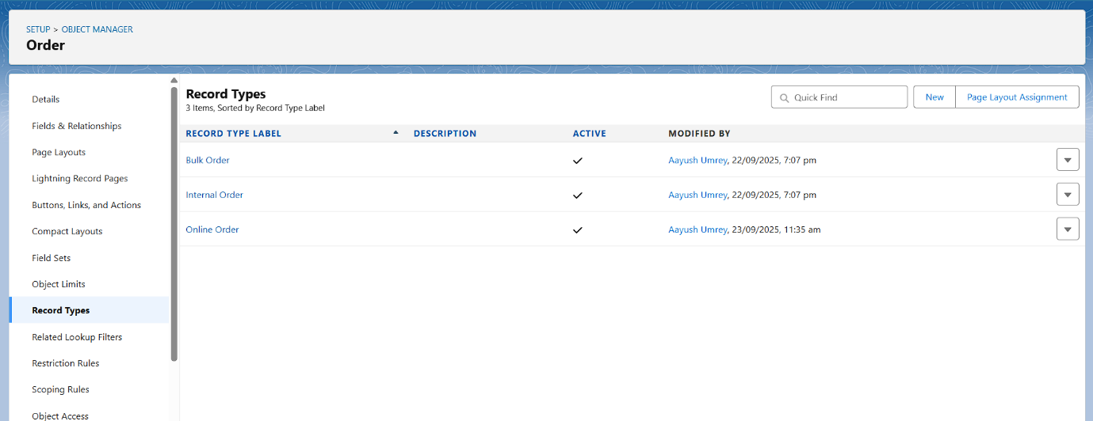

**Page Layouts:**

**Account:**

**B2C Account Layout:** Shows fields relevant for individual consumers, e.g., Payment Method.

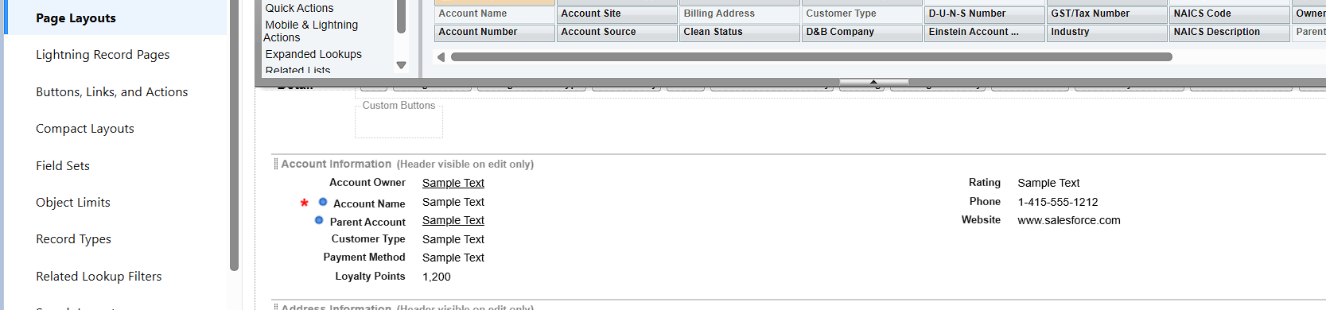

**B2B Account Layout:** Shows fields relevant for business clients, e.g., Company Type, Annual Revenue, Industry**.**

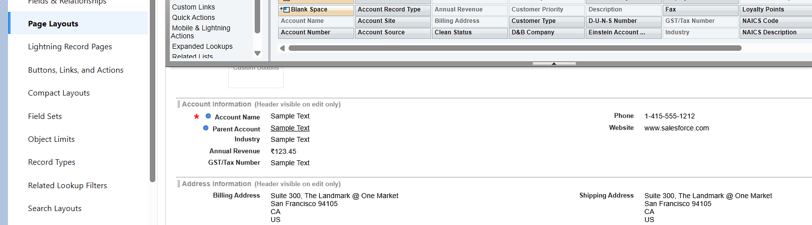

**Order:**

**Online Order Layout:** Displays fields like Delivery Method, Payment Gateway, Shipping Address.

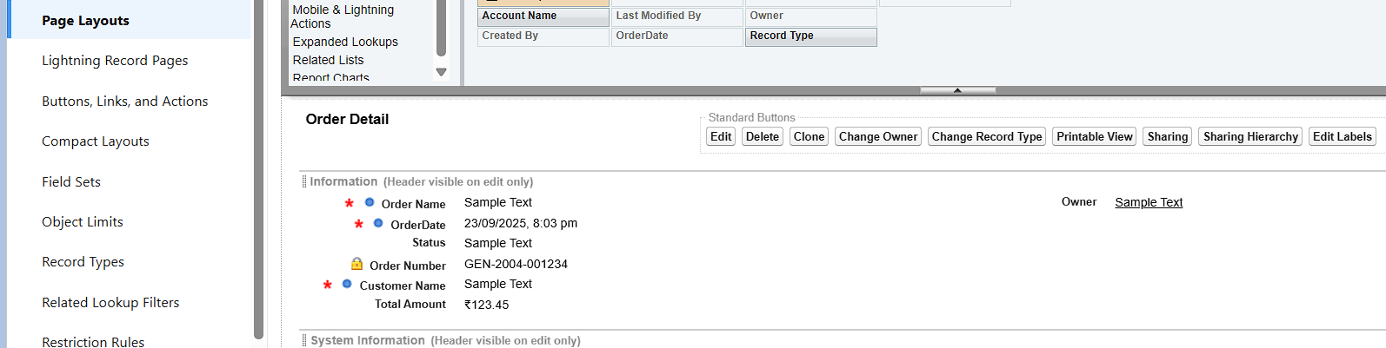

**Bulk Order Layout:** Displays fields like Discount Rate, Bulk Quantity, Order Terms

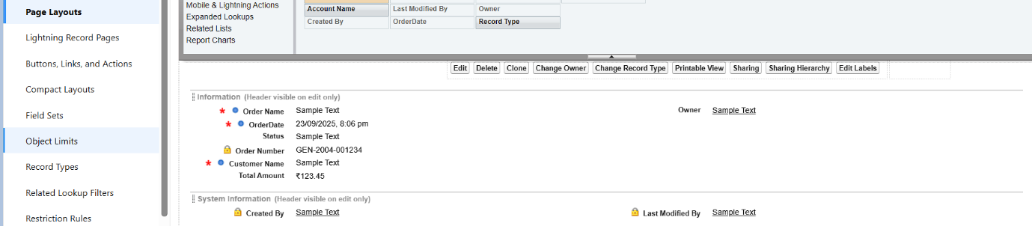

**Internal Order Layout:** Displays fields like Internal Notes, Assigned Staff, Department.

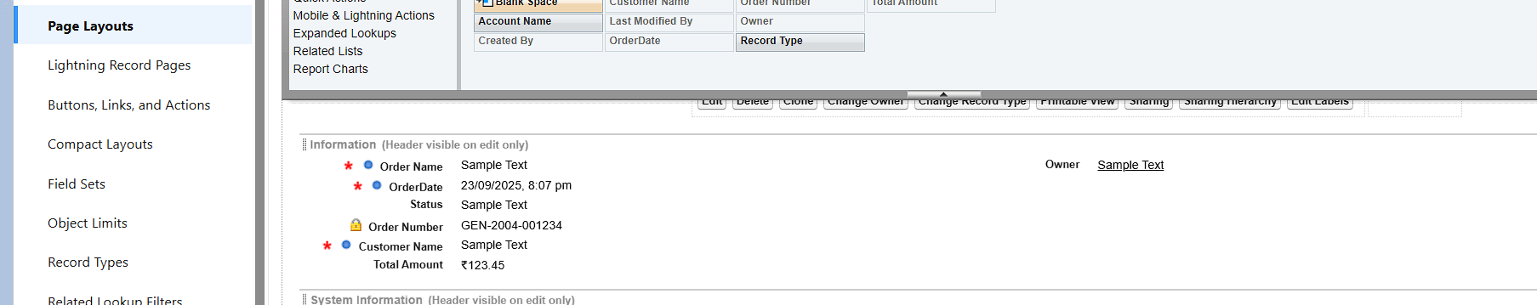

**Inventory:**

**Inventory Layout:**

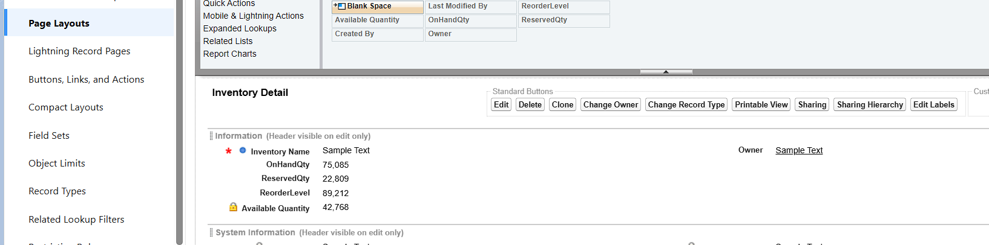

**Product:**

**Product Layout:**

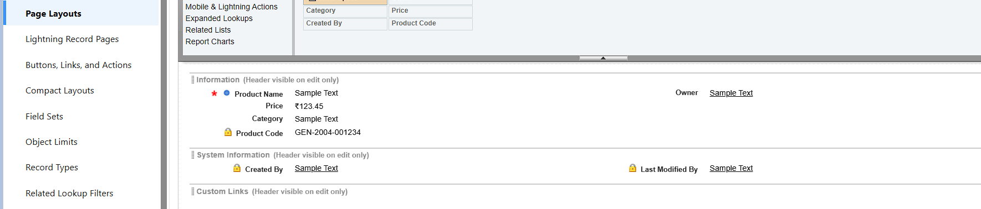

**Order Item:**

**Order Item Layout:**

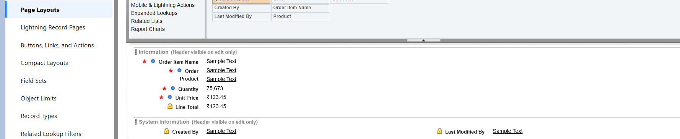

**Compact Layouts:**

**Account-Info:**

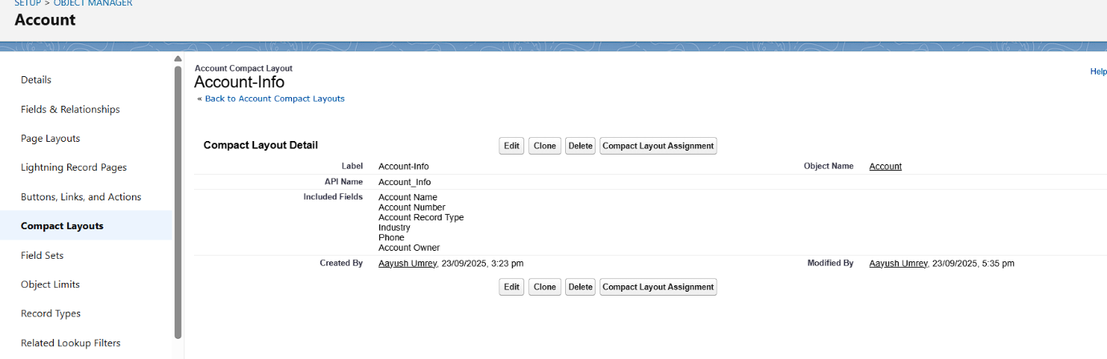

**Order-Info:**

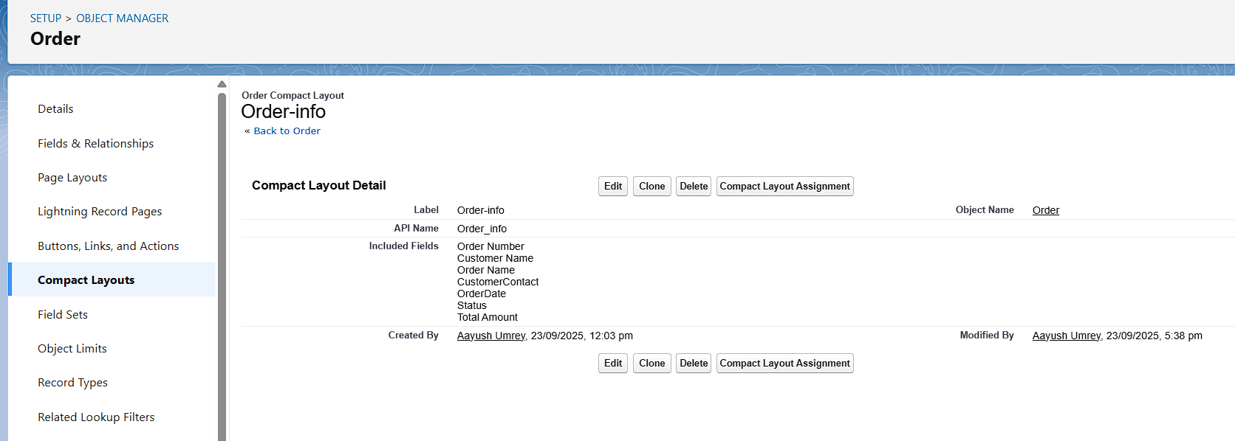

**Order Item-Info:** 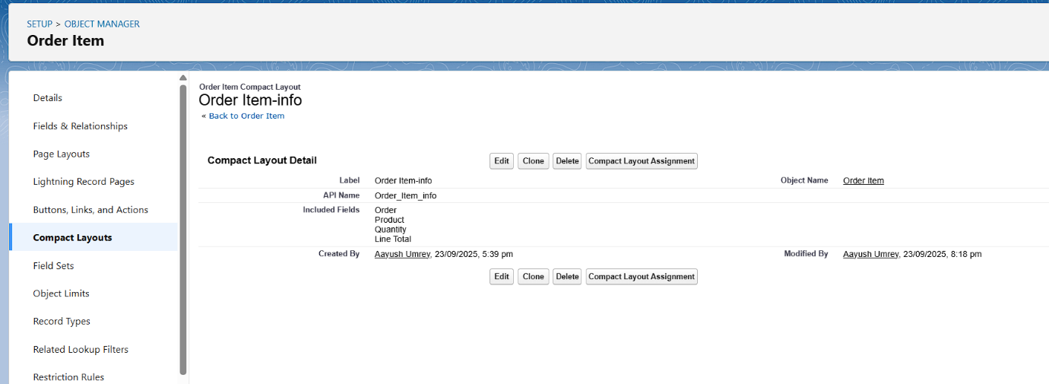

**Product-Info:**

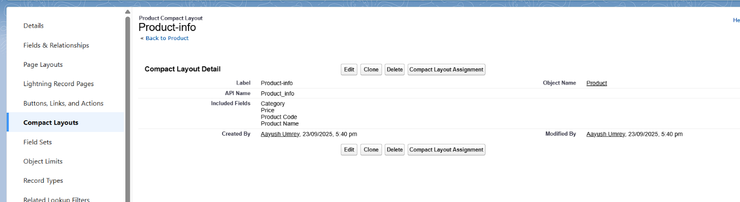

**Inventory-Info:**

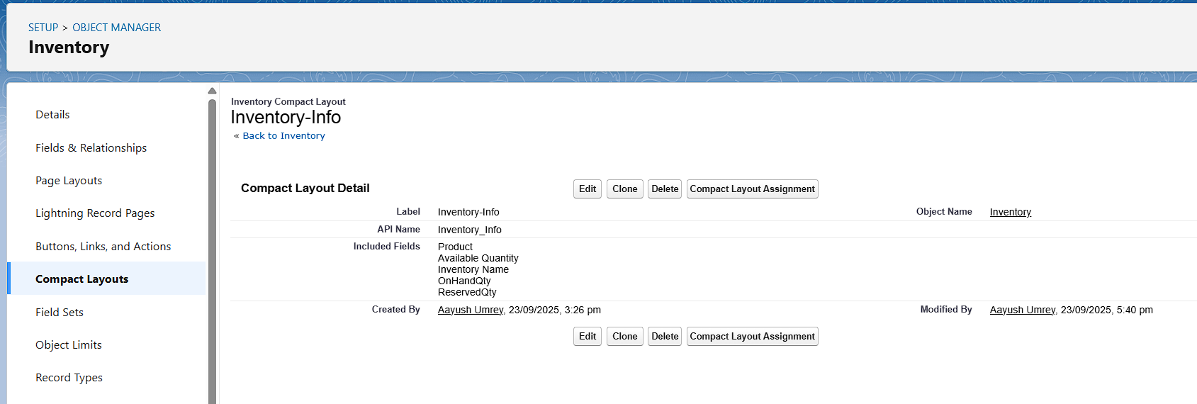

**Schema Builder:**

**Objects included:** Account, Contact, Order, Order Item, Product, Inventory.

**Relationships:**

* **Account ↔ Contact**
* **Order__c** linked to **Account** and **Contact**
* **Order_Item__c** as a child of **Order__c** (Master-Detail)
* **Order_Item__c** linked to **Product__c**
* **Inventory__c** linked to **Product__c**

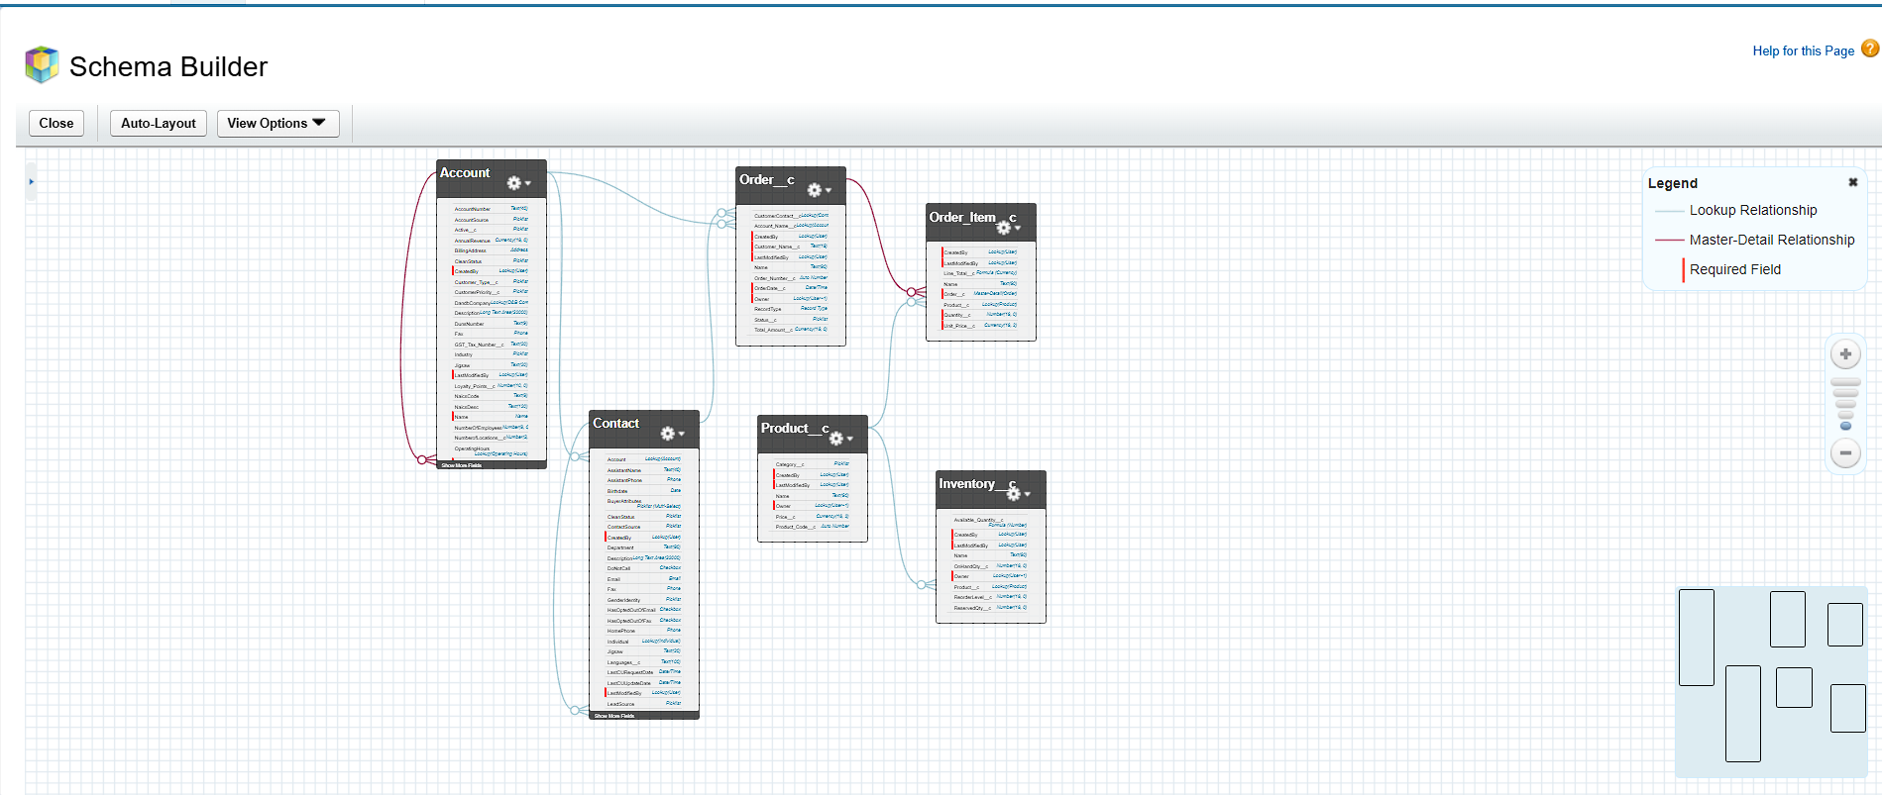

**Lookup vs Master-Detail vs Hierarchical Relationships**

**- Lookup Relationships: A loose relationship between two objects. One object “looks up” to another. (Implemented)**

**- Master-Detail Relationships: A tight relationship where the child record’s existence depends on the parent. (Implemented)**

**- Hierarchical Relationships: A special relationship available only for the User object. It allows a user to be linked to another user. (Not Implemented)**

**Junction Objects:**

**Order Item is used as a junction object to manage many-to-many relationships**

* One Order can contain many Products.
* One Product can belong to many Orders.

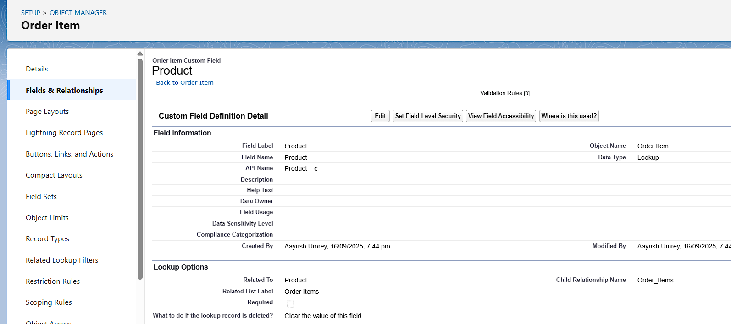

**External Objects:**

External Objects are not implemented in Developer Edition but documented for future integration.

* External objects are similar to custom objects, but their data resides outside Salesforce (e.g., in an external database, ERP system, or web service).
* Salesforce connects to the external data using Salesforce Connect.
* External objects allow you to view and interact with external data in real-time without importing it into Salesforce.